CS223 LAB1

Tolga Han Arslan 22003061

# Half adder Schematic:

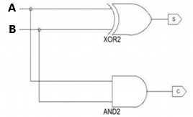

1

3

2

'86

1

3

2

'08

IC List:

1- One 74LS86 quad 2-input XOR gate 2- One 74LS08 quad 2-input AND gate

*74LS86

GND - 7

+5V - 14

*74LS08

GND - 7

+5V - 14

# Half subtractor Schematic:

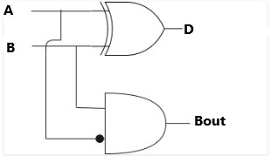

1

'86

3

2

2

3

1

'08

IC List:

1. One 74LS86 quad 2-input XOR gate

*74LS86 *74LS08

1. One 74LS08 quad 2-input AND gate

GND - 7

+5V - 14

GND - 7

+5V - 14

# Full adder Schematic:

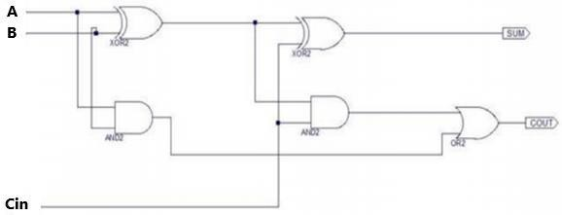

1

2

'86

3

4

6

5

'86

1

2

4

'08

3

6

1

5

'08

3

2

'32

IC List:

*74LS86 *74LS08 *74LS32

1- Two 74LS86 quad 2-input XOR gate 2- Two 74LS08 quad 2-input AND gate 3- One 74LS32 quad 2-input OR gate

GND - 7

+5V - 14

GND - 7

+5V - 14

GND - 7

+5V - 14

# Full Subtractor Schematic:

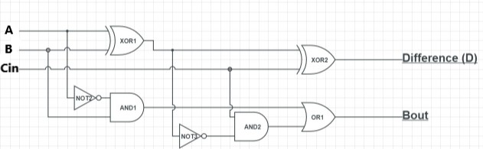

1

'86

3

2

4

'86

6

5

1 '04

2 1

'08

3

1

'32

3

2

5 '08

'04

6

2

3

4

4

IC List:

1- Two 74LS86 quad 2-input XOR gate 2- Two 74LS04 quad 2-input AND gate 3- One 74LS32 quad 2-input OR gate 4- Two 74LS04 HEXInverting gate

*74LS86

GND - 7

+5V - 14

*74LS32

GND - 7

+5V - 14

*74LS04

GND - 7

+5V - 14

*74LS08

GND - 7

+5V - 14

# 3 Input XOR Schematic:

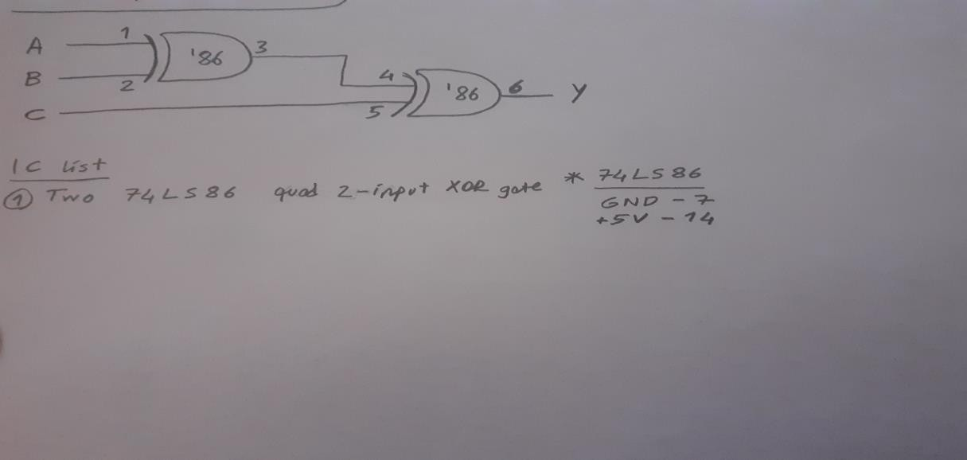

Lab calculator schematic:

